An EM61Lite Survey to Detect and Delineate
a Buried Pipeline: Preliminary Results
Authors: R.S. Bell* and G.N. Young**

The EM61Lite is a innovative time domain electromagnetic (TDEM) geophysical system manufactured by Geonics, Inc. designed for use with a small unoccupied aerial system (UAS) to detect buried metal hidden within the subsurface. The electronic specifications are the same as the EM61 Mk2 ground based system. Fitted to a Matrice 600 Pro UAS, it proved to be a highly effective and efficient tool for scanning a one (1) acre parcel to detect and delineate an undocumented vintage pipeline and buried metallic objects.
Metal detectors utilize electromagnetic (EM) induction to stimulate the flow of electrical current within a metal object which, in turn, produces a secondary magnetic field radiating from the object. The measured quantity is the amplitude of the magnetic field in the vertical direction. For the EM61Lite, an electric current is pulsed through a “transmitter” coil as it passes over the surface of the earth. A co-located receiver coil is used to measure the amplitude of the resulting vertical component of the secondary magnetic field at four (4) discrete points in time after the transmitter pulse is turned off. Like most geophysical surveys, the EM response is measured along a set of parallel traverse lines with the sensor system kept a consistent distance above the ground service. For this project the spacing of the survey traverse lines was approximately 5 meters (~16.4 ft). The altitude of the transmitter coil was a constant distance of approximately 1 m above ground level (AGL). Data were acquired for two (2) flight blocks, one oriented north-south and the other oriented east-west.
The data from the two (2) surveys were individually processed then aggregated to create a single data volume and processed again. The results from the individual surveys are unique. Thus, the orientation of the EM61Lite system as well as flight line direction are critically important parameters when designing an EM survey. Combining the data for the two (2) surveys improved the overall interpretability of the data.
The preliminary results clearly show a north-south water line on the western half of the project area which we learned after the survey was known. In addition, the EM data indicate a north-south striking undocumented pipeline in the eastern half of the property. In addition, the data suggest the presence of possibly two (2) underground storage tanks and the several small diameter pipelines or utility lines.

This project was supported by Texas Department of Transportation.

* Senior Geophysicist, Drone Geoscience, LLC (corresponding author)
** Research Specialist, Texas A&M Transportation Institute
Author Biographies
Ronald S. Bell
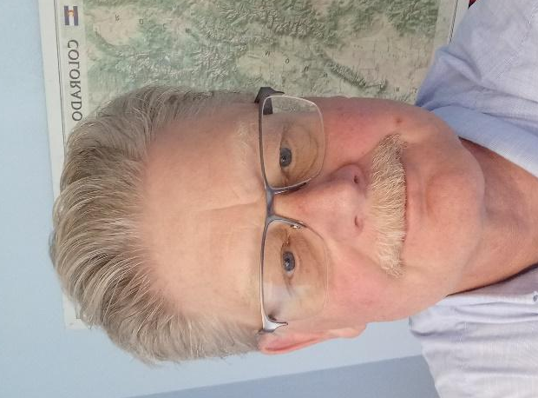
Ron has 40+ years of experience in the collection, processing, visualization, and interpretation of ground magnetic and electromagnetic data. He began using drone for geoscience applications in 2016, when he became the second person to test fly the prototype of the innovate magnetometer known as the MagArrow_{TM}. He has successfully executed numerous drone magnetic surveys to locate legacy oil and gas wells and pipelines as well as to map geology for groundwater and mineral exploration. He is currently focused on the developing the processes for safely and cost effectively acquiring EM 61 Lite data to precisely locate pipelines and the detection and delineation of buried metallic objects. He began his career in geophysics soon after receiving a BS in Applied Physics from Michigan Technological University.
Email: ron@dronegeosci.com. tel #: 720-220-3596.

Gary Young
Gary Young is a geophysicist by training. He has worked in research and operations in several industries including mining, oil and gas, environmental and transportation and utilities. He has worked for ExxonMobil Upstream Research, Argonne National Laboratory, Caterpillar, Inc., and now Texas A&M Transportation Institute. Over the past 20 years or so he has focused on investigation and mapping of utilities and more lately on broader aspects of utilities. For several years he ran the Underground Imaging Technologies unit of Caterpillar which was a utility mapping and SUE company. His current interests are utilities in the ROW and associated business processes.

